Considerable interest attaches to the thermal performance of solid-wall historic buildings – what it is, and how it can be improved in such a way as to retain the character of the building, and to avoid introducing damp problems and to maintain good air quality.

This is relevant to the wider question as to the relative life-cycle impact of retrofitted historic buildings as against an alternative strategy of demolition and replacement. However improved the thermal performance of a retrofitted historic building, for practically reasonable wall thicknesses and at affordable costs, it is likely to be worse than that of a new-build, leading to higher in-use energy and emissions. The question arises as to what extent this is mitigated by the possibly lower embodied energy and carbon of the retrofit, and how this is affected by choice of materials.

We have carried out a series of heat flow measurements in the Stable Block of historic Rosewarne House, which has been retrofitted as four residential units. We present here results from one of them (Unit A), in which conventional cement based products and dry-lining with PUR closed cell foam has been used, and another (Unit A) in which breathable products were used instead. The construction details are described elsewhere in this paper. We also present estimates of the embodied, in-use and overall energy and carbon of each unit, and also for a conventional masonry/cement products new build, all values normalised for floor area.

Each of the stable block units has solid walls about 600 mm thick that comprise granite facing stones and an interior that contains an unknown mix of stone, earth and air voids. This already makes an estimate of the thermal resistance of these walls problematic. If the stones are presumed also to be granite, and if the earth/stone mix in the interior is in the range 20/80 to 80/20, then a steady state calculation such as a conventional U-value calculator would yield estimates the R value of the bare stone wall to be in the range 0.37 to 0.65 W-1 K m2, giving a U-value in the range 1.5 to 2.7 W K-1 m-2. With the addition of the internal insulation and finishing, steady state calculations give U values for the finished walls in the range 0.31 – 0.34 for unit A, and 0.74 to 0.94 for Unit D.

However, direct heat flux measurements by other authors (see, for example Baker (Baker, 2011) and (Biddulph *et al.*, 2014) have consistently shown that the actual U-value of thick solid walls is lower than the steady-state value, at least in the climate of the UK. That the steady-state calculations fail should not be surprising, since the period of diurnal temperature variations is shorter than the time required for a steady state to be achieved.

The heat flux measurements were carried out over several days in the same manner as the authors mentioned, using thermistors pressed to the interior and exterior surfaces to measure temperatures *T*in and *T*out, together with a Hukseflux HP5 heat plate on the interoir wall surface to measure the heat flux *Q*. The data were analysed in the manner of Biddulph and co-workers (Biddulph *et al.*, 2014), in which the walls were modelled as two thermal resistances *R*1 and *R*2, linked to an internal wall heat capacity *C*, with the initial temperature of the wall interior parametrised as *T*m,init. Given a choice of these parameters, and given the actual values of *T*in(*t*) and *T*out(*t*), one can generate a time series for the heat flow *Q*(*t*). Whereas Biddulph and co-workers then used a Bayesian analysis to find the parameter values that gave the best fit, we used maximum likelihood estimation, using the mle() function in R.

Plots of the temperature measurement and real and modelled heat flow measurements are shown in Figure 1.

The outcome of the modelling exercise is that we find that the walls of Unit D have a thermal resistance of 2.65 W-1 K m2, and so a U-value of 0.39 W K-1 m-2, while the corresponding values for Unit A are 2.96 W-1 K m2 and 0.34 W K-1 m-2 respectively. In the same manner, we also measured the U-value of the bare walls of unit A before insulation was applied, and found it to be 1.3 W K-1 m-2.

The method of analysis used here means that these results are valid despite the in some cases short measurement periods, and despite that on occasion the internal temperature exceeded the external temperature.

These results are in line with those of Baker and Biddulph and co-workers, in that the U-values are lower than steady-state calculations would suggest.

The impact of this reduced difference in U-value, between what is achievable with modern materials and what is achievable with historic, breathable materials in thick , solid-walled buildings, has a considerable impact on the relative life-cycle impacts of the two type of construction.

We have used a process model, using embodied energy and carbon values from the Bath University Inventory of Carbon and Energy (Hammond and Jones, 2011), in addition to a simplified building physics model based on SAP (BRE, 2012) to estimate the embodied and in-use carbon and energy of each of the units, in addition to that of a new-build residence of the same size. We assume that heating is provided by a 90% efficient gas boiler, and use a natural gas carbon intensity 0.184 kg CO2e / kWh (Department for Environment, 2015). of We do not include contributions from construction or repair and refurbishment. Work to include these is under way. However we do include the energy and carbon that would arise from demolition and disposal in the case of rebuild from new strategy. To do, we use the result of Moncaster and Symons (Moncaster and Symons, 2013), which is that this part of the life cycle accounts for 21% of embodied carbon and 5% of embodied energy.

The results are summarised in Table 1 below:

Table 1: Summary of the embodied, in-use and lifetime (50 year) energy and carbon of the two retrofitted units and a conventional new-build of the same size.

|  |  |  |  |  |
| --- | --- | --- | --- | --- |
|  | | Unit A | Unit D | New Build |
|  | Wall construction | 600 mm granite/earth/50 mm PUR closed-cell foam | 600 mm granite/earth/60 mm cork board/NHL finishing render | 2 leaves of 100 mm concrete block, 125 mm cavity inc. 75 mm PUR closed-cell foam. |
| Embodied Energy (kWh m-2) | 458 | 183 | 792 |
| Embodied carbon (kg CO2 m-2 ) | 138 | 80 | 298 |
| Steady state | In-use energy (kWh m-2) | 48.3 | 87.1 | 22.1 |
| In-use carbon (kg CO2 m-2 ) | 8.9 | 16.1 | 4.1 |
| Lifetime energy (kWh m-2) | 2874 | 4537 | 1972 |
| Lifetime carbon (kg CO2 m-2 ) | 585 | 886 | 627 |
| Dynaimc | In-use energy (kWh m-2) | 47.4 | 58.6 | 22.1 |
| In-use carbon (kg CO2 m-2 ) | 8.8 | 10.8 | 4.1 |
| Lifetime energy (kWh m-2) | 2829 | 3114 | 1972 |
| Lifetime carbon (kg CO2 m-2 ) | 576 | 622 | 627 |

A striking result is that proper consideration of the dynamic nature of heat flow through the thick walls of the historic properties considered here means that the lifetime carbon emissions of the retrofitted units are seen to be comparable to those of the new build, even for the unit in which less thermally insulating cork was used. Without this dynamic treatment, an incorrect view that the emissions are in fact considerably greater would be arrived at.

Moreover, there is scope for the natural product retrofit in particular to achieve lower emissions than either the modern material or new build options, given the likely reduction over coming decades in the carbon intensity of electricity, if space and water heating were switched to an electrical form.

It is noteworthy that the cork boards and plasters used in the Unit D, as well as the slates used for roofing used in all units were imported from Portugal and Spain. Using carbon intensities supplied by DEFRA , we find that the additional transport emissions due to this distance of travel are less than 1% of the lifetime building emissions, and thus not a major consideration.

Further work will seek to establish any difference expected in energy and emissions due to lifetime refurbishment and repair, in particular to determine whether use of breathable materials for insulation confers advantages in terms of damp avoidance and air quality.

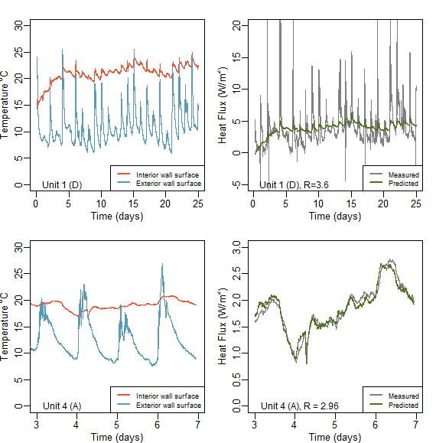

Figure 1: (left panels): Interior and exterior wall surface temperatures of the two retrofitted units studied within the stable block at Rosewarne House. (right panels): measured (grey) and modelled heat fluxes through the walls of these units.

References

Baker, P. (2011) ‘Historic Scotland Technical Paper 10: U values and traditional buildings’. Historic Scotland. Available at: http://www.historic-scotland.gov.uk/technicalpaper10.pdf.

Biddulph, P., Gori, V., Elwell, C. A., Scott, C., Rye, C., Lowe, R. and Oreszczyn, T. (2014) ‘Inferring the thermal resistance and effective thermal mass of a wall using frequent temperature and heat flux measurements’, *Energy and Buildings*, 78, pp. 10–16. doi: http://dx.doi.org/10.1016/j.enbuild.2014.04.004.

BRE (2012) *Standard Assessment Procedure (SAP 2012)*. Available at: http://www.bre.co.uk/sap2012/page.jsp?id=2759 (Accessed: 27 May 2016).

Department for Environment, F. and R. A. (Defra) C. D. webmaster@defra. gsi. gov. u. (2015) *DEFRA Carbon Factors*. Available at: http://www.ukconversionfactorscarbonsmart.co.uk/ (Accessed: 12 December 2015).

Hammond, G. and Jones, C. (2011) ‘Embodied Carbon: The Inventory of Carbon and Energy’. BSRIA.

Moncaster, A. M. and Symons, K. E. (2013) ‘A method and tool for “cradle to grave” embodied carbon and energy impacts of UK buildings in compliance with the new TC350 standards’, *Energy and Buildings*, 66, pp. 514–523. doi: 10.1016/j.enbuild.2013.07.046.